CLOUD COMPUTING
SUBMITTED BY: ARMEEN ABID (BSE-011)
SUBMITTED TO: ENGR.MUHAMMAD SHOAIB
LAB 09
TASK 1:
GitHub CLI, Codespace setup and authentication
Install GitHub CLI (local machine)
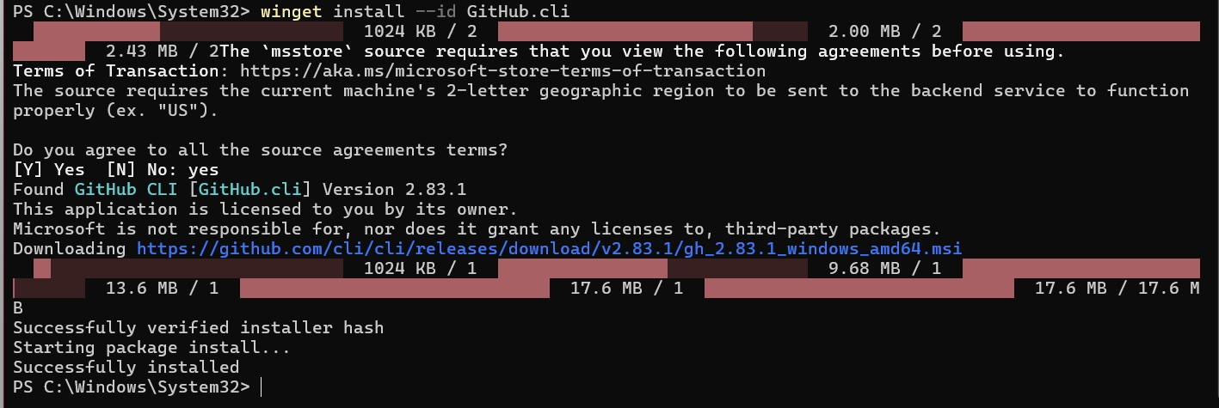

Authenticate GH CLI for Codespaces (local machine):
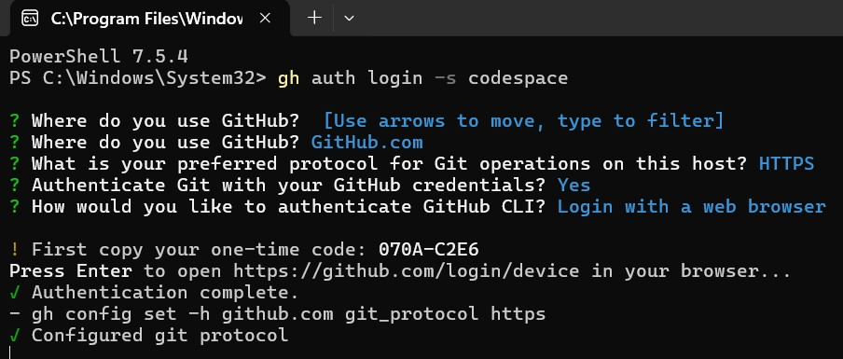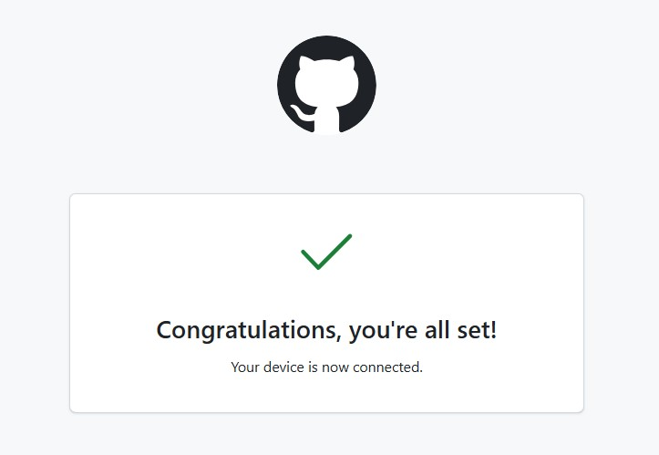

List and Create Codespace:
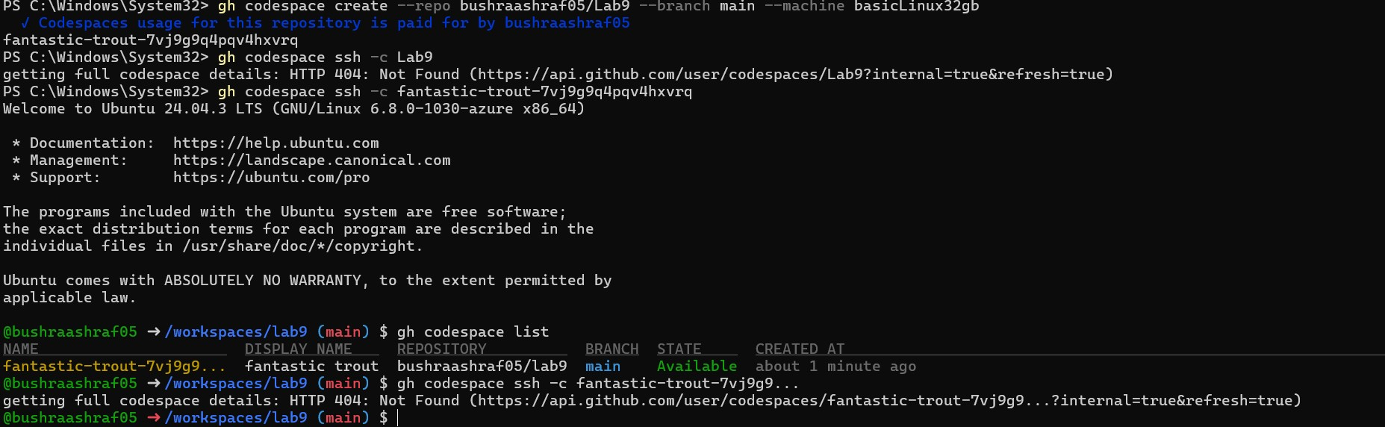

TASK 2

Install AWS CLI inside the Codespace and configure it
Download and install AWS CLI
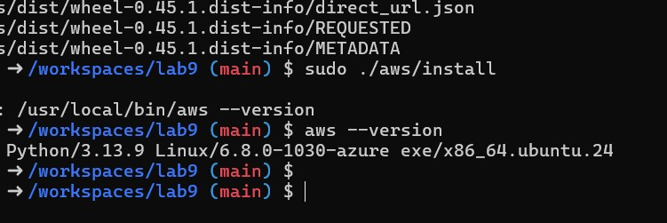

Verify credentials and config files
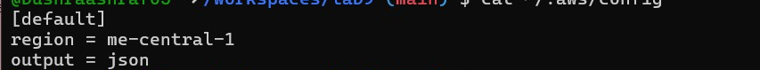
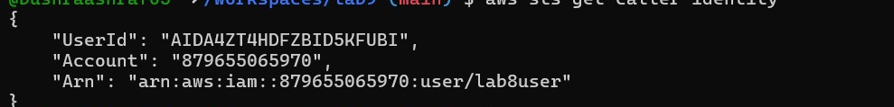
TASK 3:
Create security group and add ingress rules using Codespace IP

Find your VPC ID
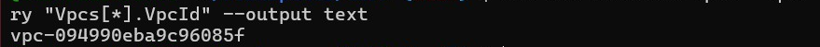
Create Security Group
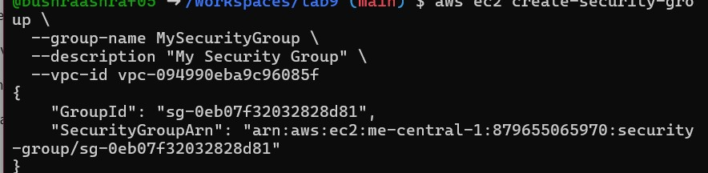
Inspect Security Group (Before Adding Rules)
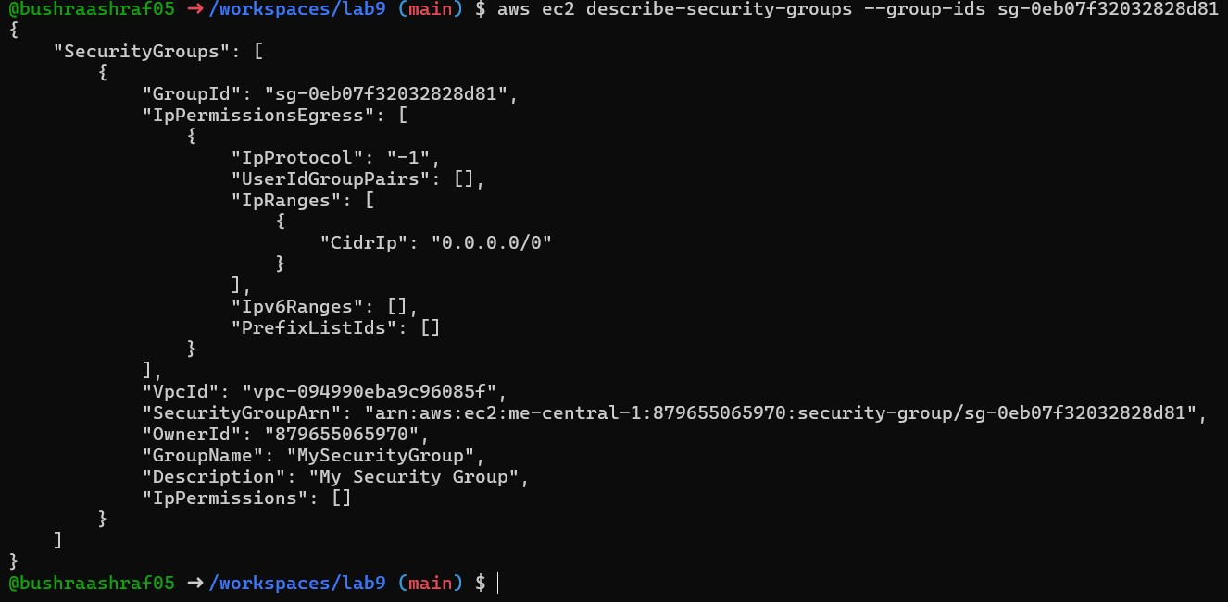
Get your Codespace Public IP
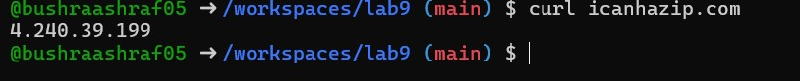
Authorize SSH Inbound (Port 22) From Codespace IP
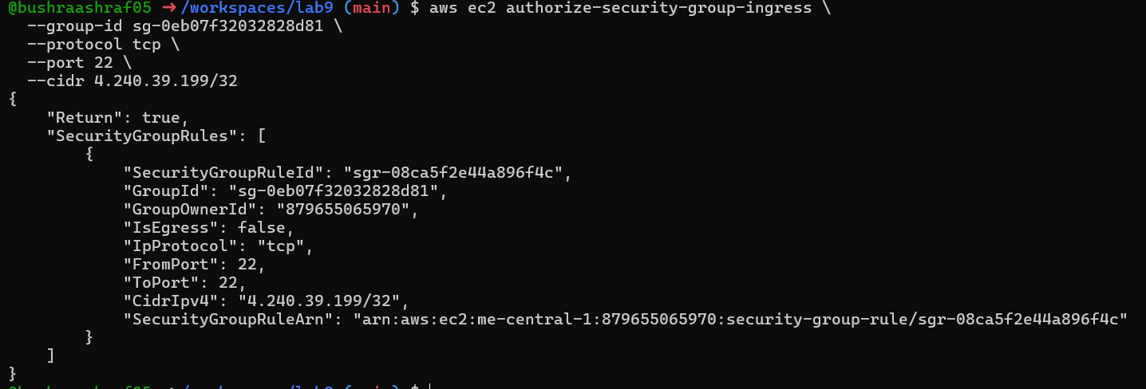
Add HTTP Rule (Port 80) Using JSON:
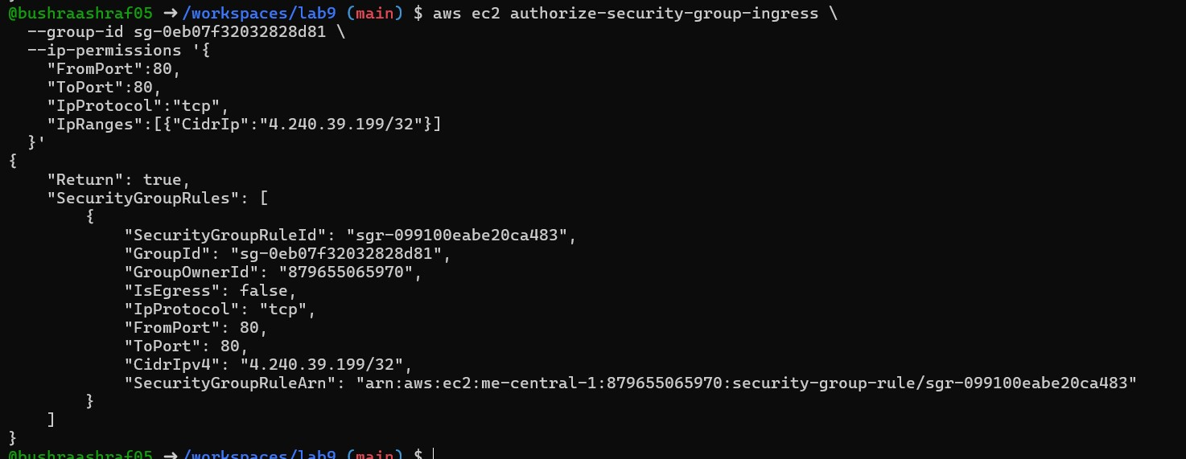
Verify Both Rules
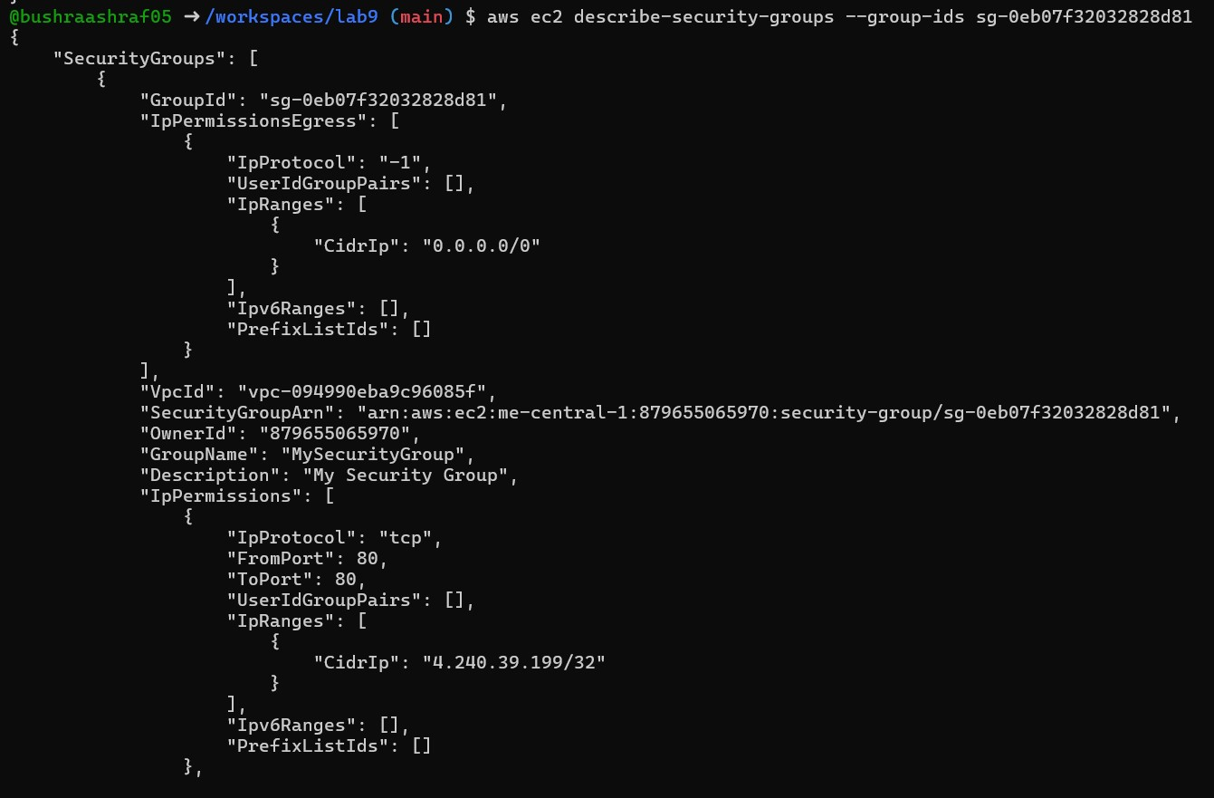
TASK 4:
Create a key pair, describe key pairs, and launch EC2 instance
Create an ED25519 Key Pair
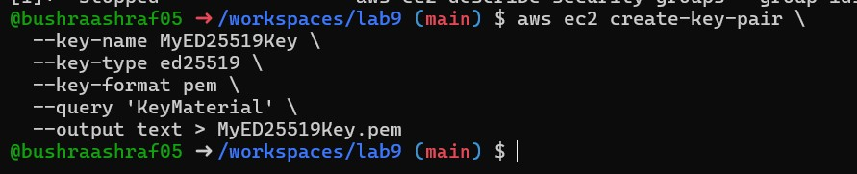
View Created Key Pairs
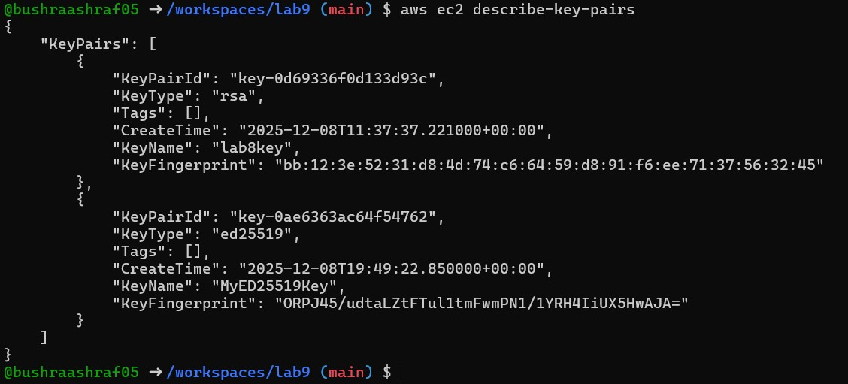
Launch an EC2 Instance
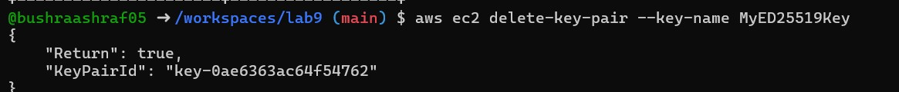
Get Public IP of the Instance:
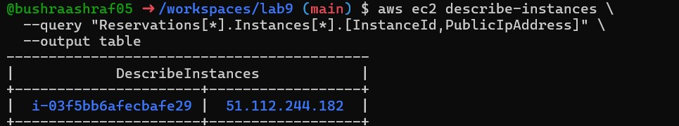
SSH Into the Instance
Stop, Start, and (Optional) Terminate the Instance
Stop the instance:
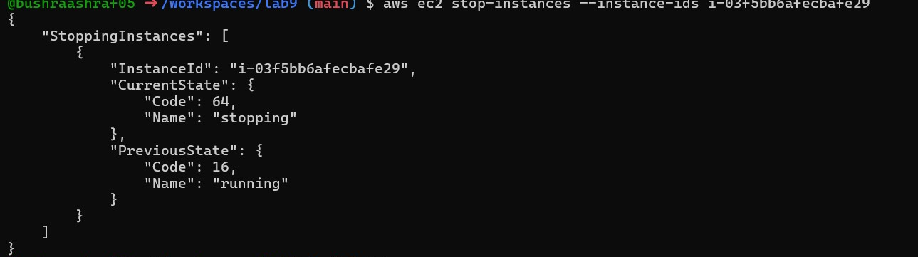
Start the instance:
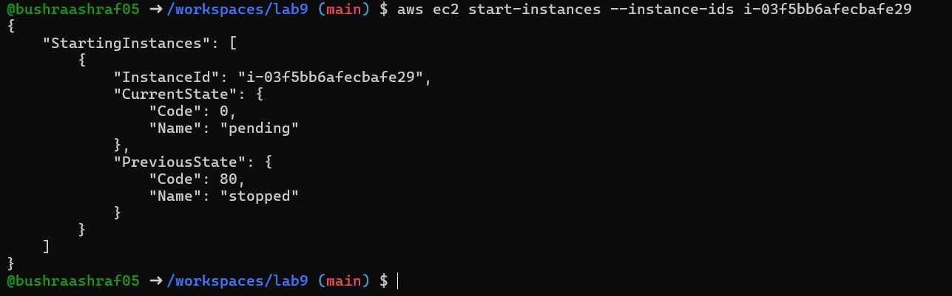
Terminate the instance:
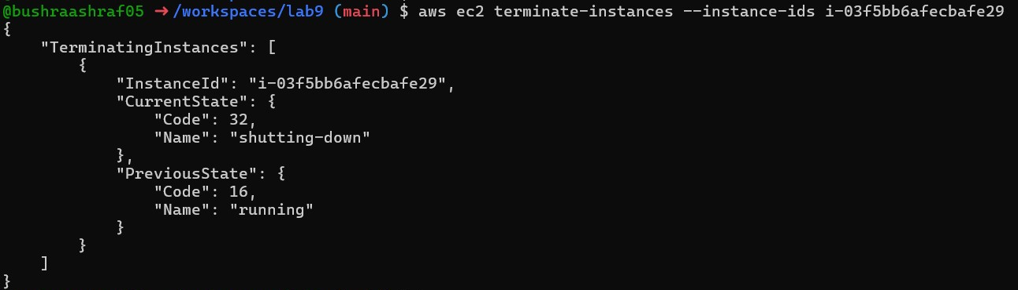
TASK 5
Understand AWS describe-* commands:
Describe Security Groups
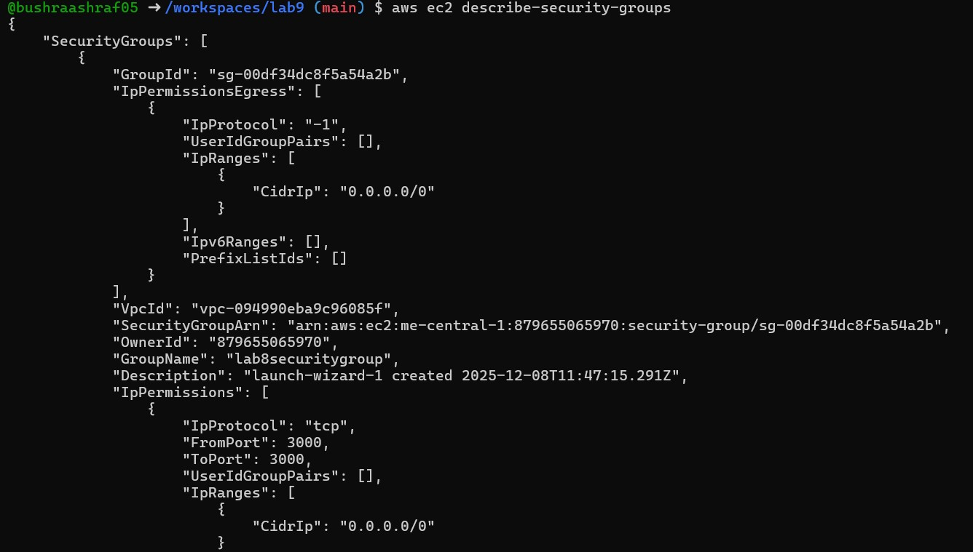
Describe VPCs
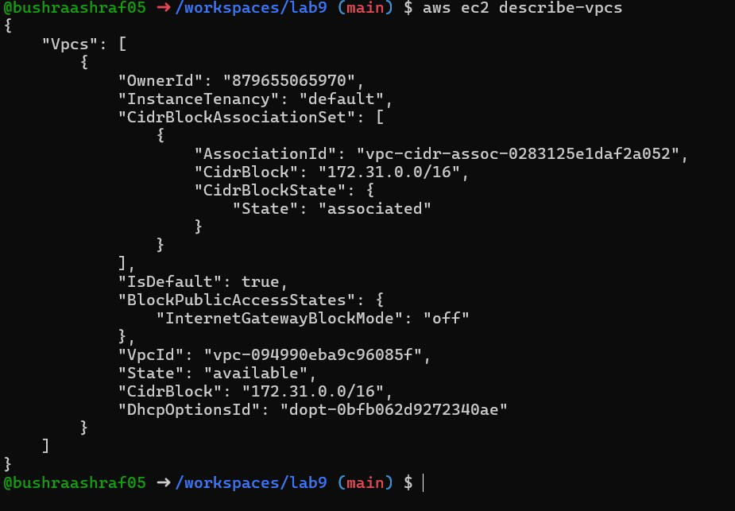
Describe Subnets
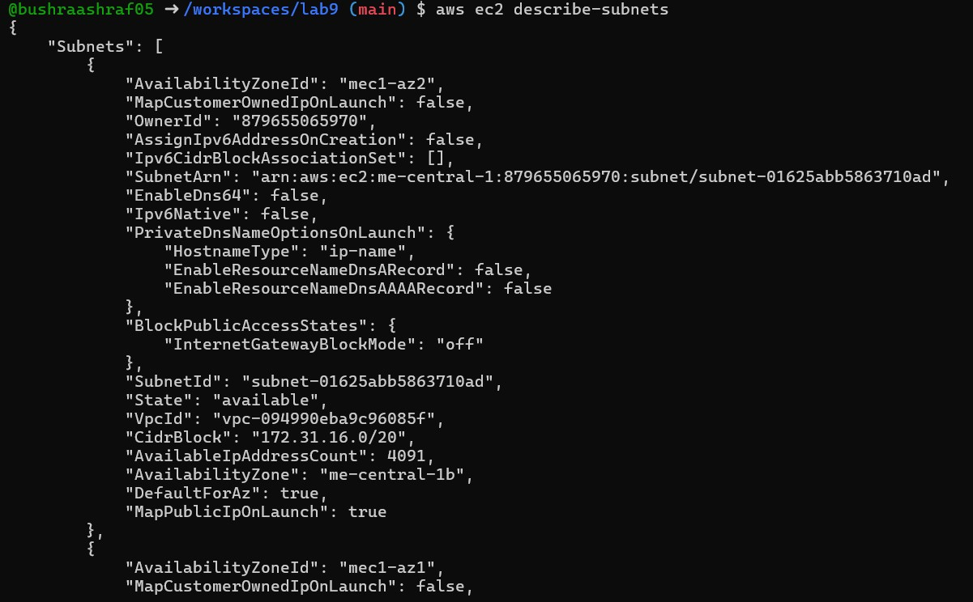
Describe Instances
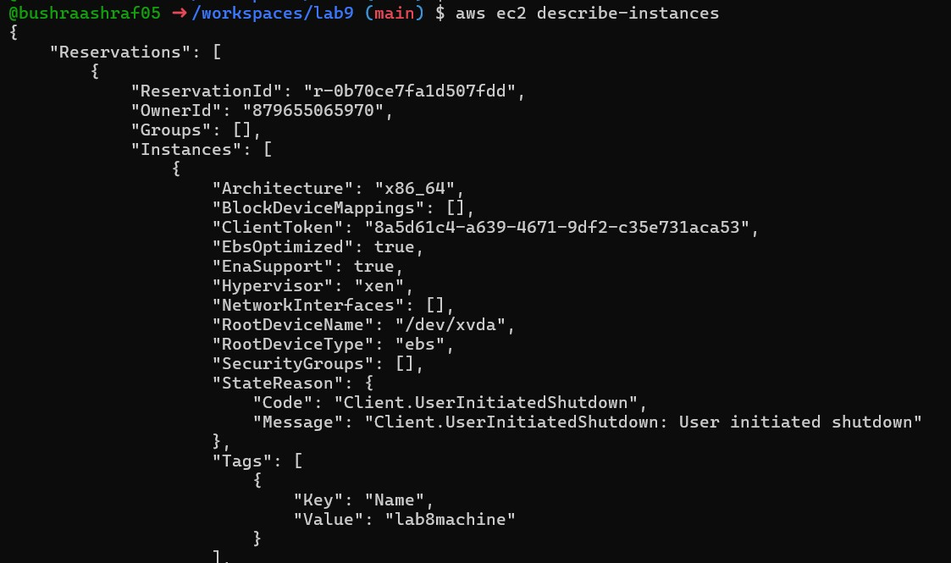
Describe Regions:
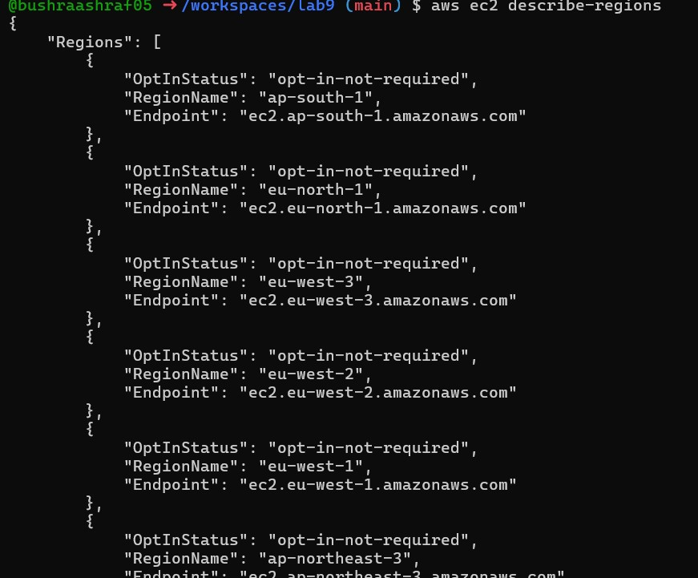
Describe Availability Zones
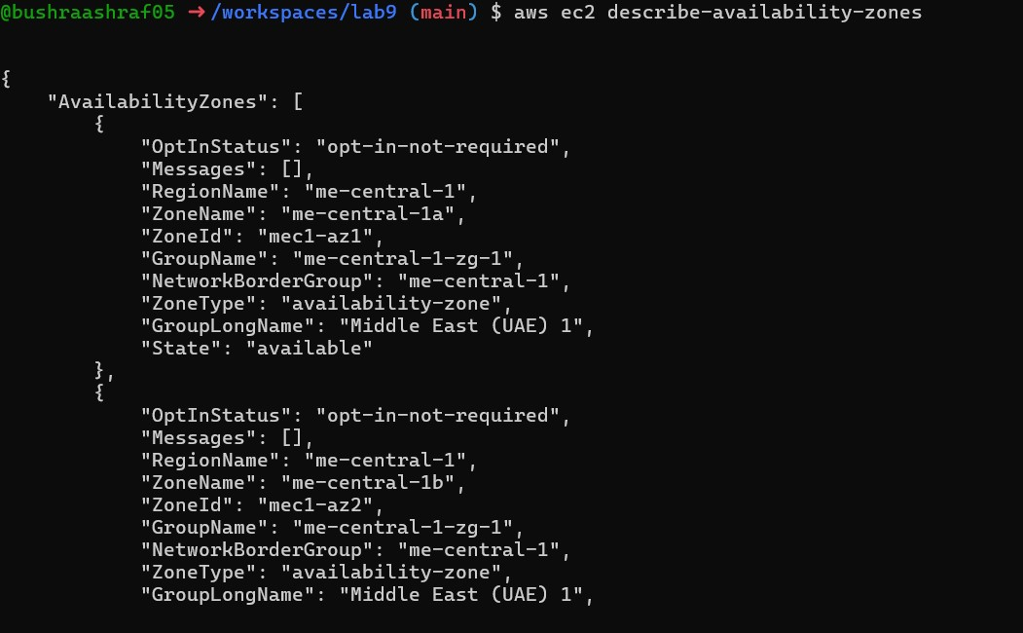

TASK 6:
create group, user, attach policies, create console login & keys.
Create IAM Group
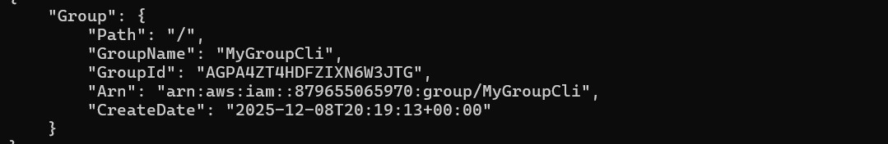
Get Group Details
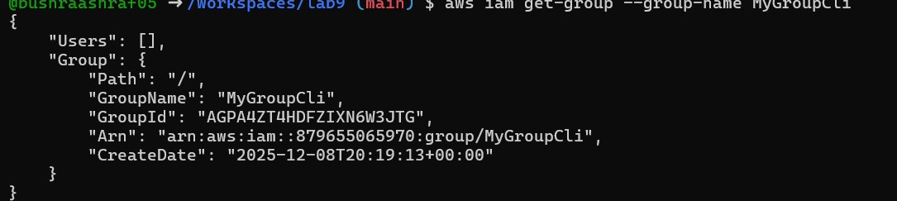
Create IAM User
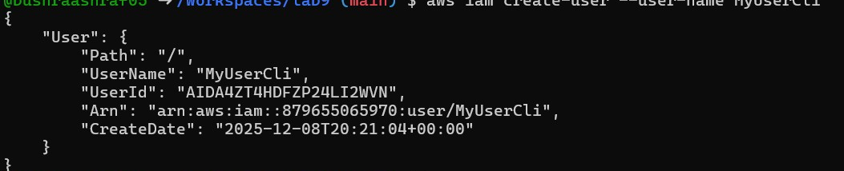
Get User Details
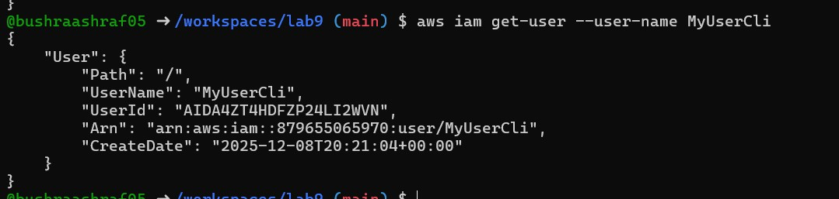
Add User to Group
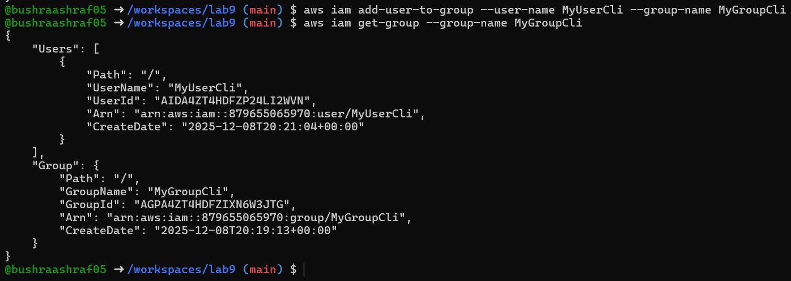
List and Attach EC2 Policy
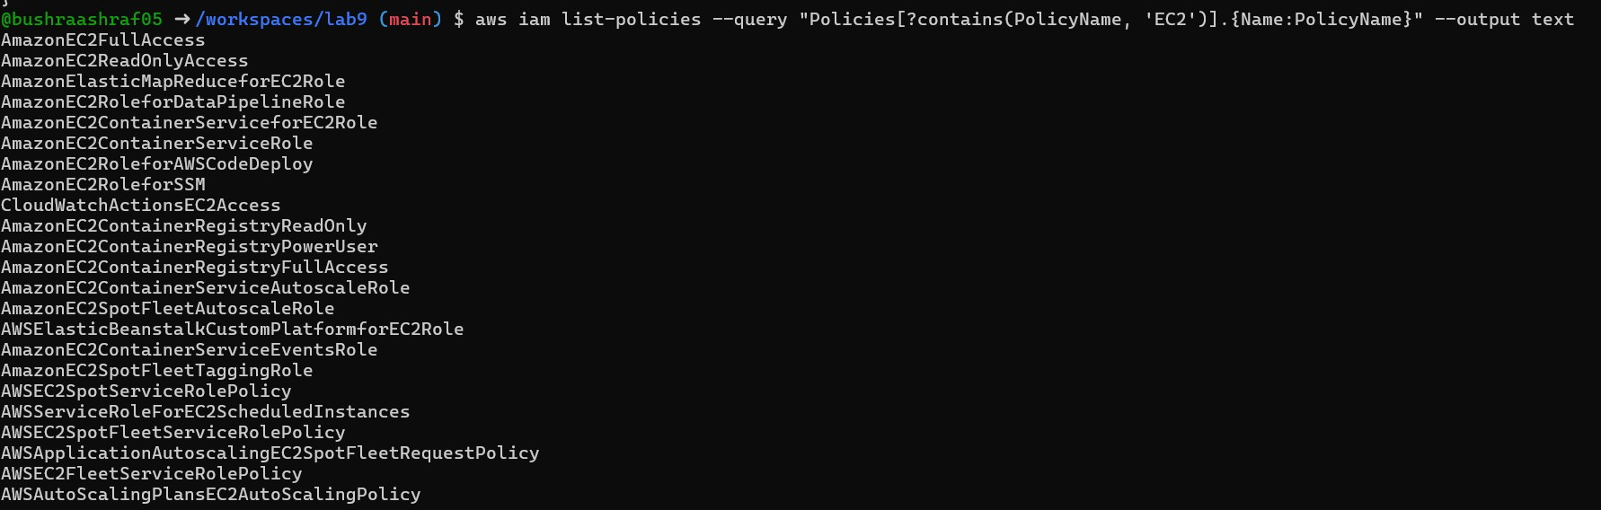
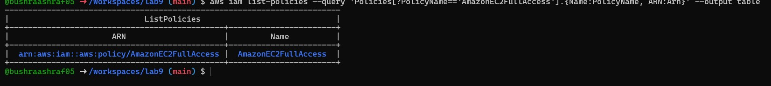
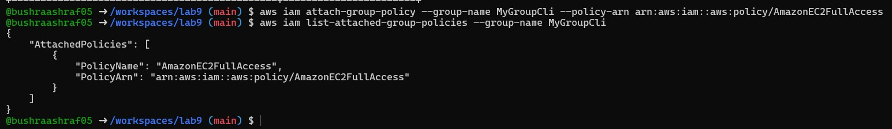
Create Login Profile for User:
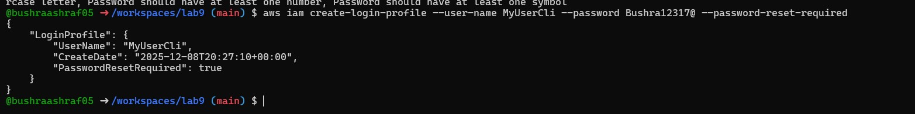
Create Access Keys
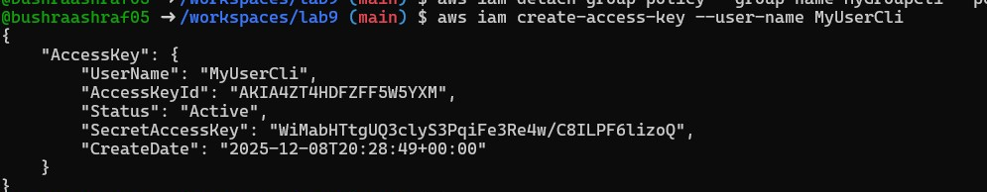
Verify keys:
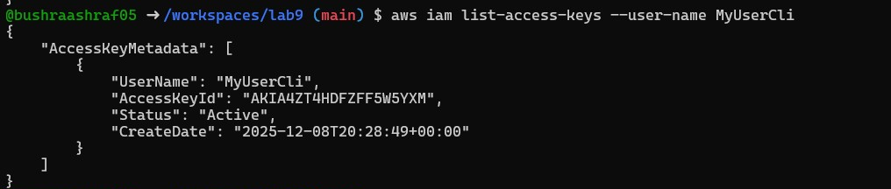
Test Environment Variables
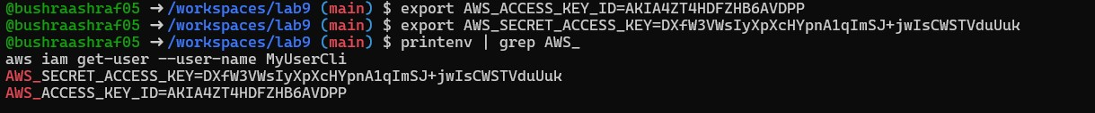
Clear Environment Variables:
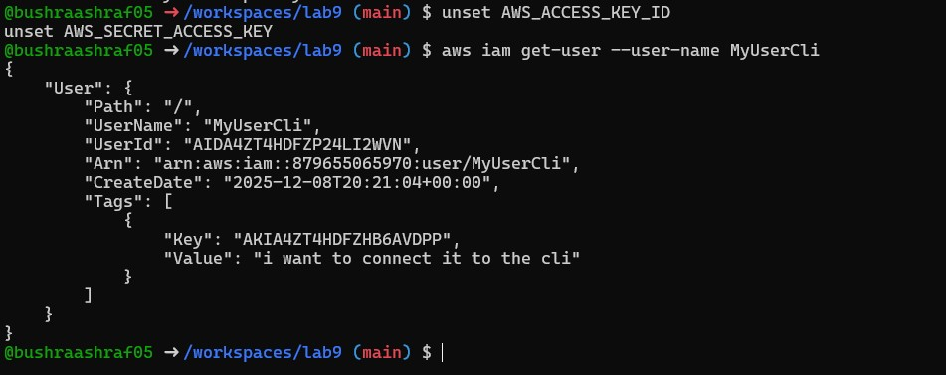
TASK 7

Filters: query with filters to find instances and their attributes
Filter by Tag Name (MyServer) → Get Public IP
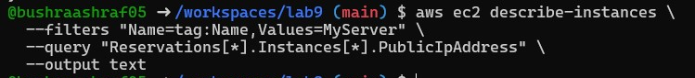
Filter by Instance Type (t3.micro) → Get Instance IDs
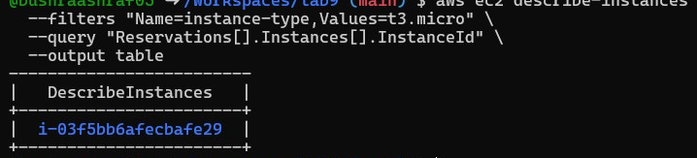
Filter by Subnet → Get Instance IDs
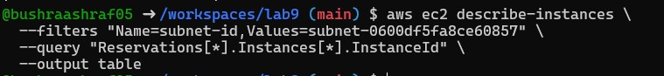
Filter by VPC → Get Instance IDs
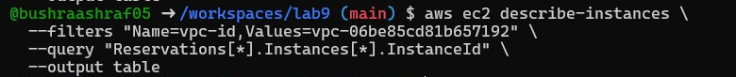
TASK 8:

Use --query to format outputs for reporting
Get InstanceId, Public IP, and Name
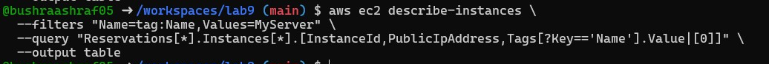
Get InstanceId and State
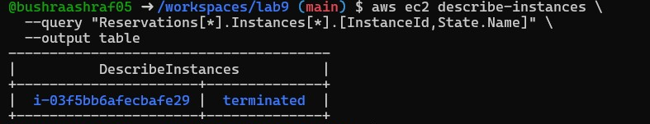
Get InstanceId, Instance Type, and Availability Zone
